CHAPTER 24
CAPACITANCE AND DIELECTRICS
Discussion Questions
Q24.1 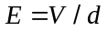 so for a given potentialacross the capacitor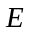 becomes larger as is decreased. Whenexceeds the dielectric strength of whatever is between the plates of the capacitor, current flows through the dielectric and the capacitor discharges.

Q24.2 The electric field between the plates is proportional to the surface charge density on the plates: 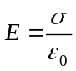. The potential difference between the two plates is related to the electric field between the plates by 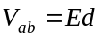. Capacitance is defined as 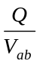. The greater the area of the plates the smaller the surface charge density for a given Q. So, with greater area the capacitor can hold more charge for the same E and V and this makes C larger. Increasing the separation between the plates increases 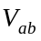for the same E and hence the same Q. Increasing decreases C.

Q24.3 Due to the attraction of the opposite charges on the plates, charge will be on only that part of the larger plate that is directly across from the smaller plate. Both the capacitor and the battery remain neutral; the two plates have charges of equal magnitude.

Q24.4 The magnitude of charge  on each plate of the capacitor is given by 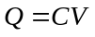. More charge is stored when is larger. 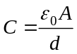 so is larger when is smaller. It is better to have the plates closer together.

Q24.5 (a) No. This is true only when is much smaller than the dimensions of the plates. (b) The electric field is no longer confined to the region between the plates so the force on a charge between the plates is less than it would be if the field was confined between the plates. The smaller force does less work on a test charge that moves from one plate to the other so the potential difference is less than given by 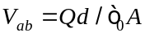 since this equation assumes the field is confined to the region between the plates. (c) 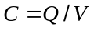 so smaller means larger 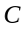.

Q24.6 The battery keeps the potential between the plates constant. so when the separation is doubled the electric field is halved. 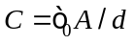 so the capacitance is halved and by 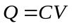 the charge on the plates is halved. Less charge is needed to produce the same potential difference when the separation is doubled. 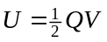 so the energy stored in the capacitor is halved.

Q24.7 Since the capacitor is disconnected from the battery, the charge on its plates remains constant. 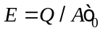 so is unchanged. 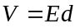 so doubles. so the total energy stored is doubled. The energy increase comes from the work done in pulling the plates farther apart.

Q24.8 The two capacitors have the same V. Let capacitor 1 have plate separation d and capacitor 2 have plate separation 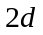. , so 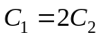. so 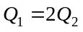. 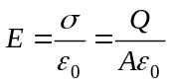 so 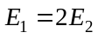. The energy density is 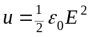 so 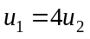. The capacitor with the smaller plate separation has the stronger electric field, the greater charge and the greater energy density. This capacitor needs more charge to produce the same potential difference between its plates.

Q24.9 See Q24.7. The energy added is stored in the capacitor. The electric field stays the same so the energy density is the same. But the volume occupied by the field increases and the total energy stored by the field increases.

Q24.10 The stored energy for a capacitor is given by 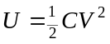. In parallel the potential difference across each capacitor equals the battery voltage whereas in series the potentials add to give the battery voltage. Therefore, the voltage for each capacitor is greater in parallel and the stored energy is greater when they are connected in parallel.

Q24.11 Water is an excellent solvent and would tend to dissolve or corrode the capacitor plates. Also, it conducts current if it contains dissolved ions and isn’t perfectly pure.

Q24.12 No, they are different. Dielectric strength is the largest the electric field can be before the dielectric becomes conducting. The dielectric constant  is a measure of the extent to which charge polarization in the dielectric cancels the electric field due to the charges on the plates. The presence of the dielectric between the plates increases the capacitance by a factor of . In Table 24.2 there is no relationship evident between dielectric strength and dielectric constant.

Q24.13 The holes are places where Mylar is replaced by air. The area of the holes is a small fraction of the total area of the charged conductors so the presence of the air makes little difference to the average electric field between the plates. But the dielectric strength of air is much less than that of Mylar and breakdown at the holes occurs when the dielectric strength of air is exceeded.

Q24.14 The surface of the dielectric closest to the positively charged plate has a negative induced charge and the surface of the dielectric closest to the negatively charged plate has a positive induced charge. The plates of the capacitor therefore exert an attractive force on the dielectric and this force does positive work on the slab as it moves into the region between the two plates. 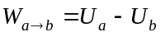 so when the force does positive work the potential energy associated with that force decreases. Therefore, less energy is stored in the capacitor after the dielectric has been inserted. We can see this from 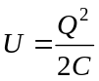. Q is constant and C increases (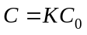), so U decreases.

Q24.15 The capacitance depends on the dielectric constant of the fish and this in turn depends on the amount of water in the fish’s tissue.

Q24.16 It is much easier to achieve a small and uniform separation between the two conductors.

Q24.17 The flux decreases by a factor of since the enclosed charge decreases by a factor of . Without the dielectric the enclosed charge is 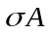and the electric flux through the surface is 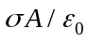. With the dielectric present the enclosed charge is 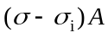. But 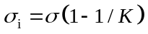 so 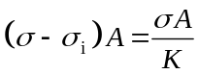 and the electric flux through the surface is 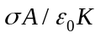.

Q24.18 The one fact that is always true is that 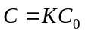, where 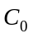 is the capacitance without the dielectric and is the capacitance with the dielectric.
Power supply keeps the voltage constant:
(i) . is constant so doesn’t change.
(ii) . increases so increases.
(iii) Use 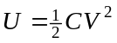. is constant and increases so  increases.
Charge kept constant:
(i) 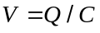. is constant and increases, so decreases. so decreases.
(ii) is constant.
(iii) Use 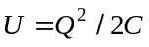. increases and is constant so decreases.

Q24.19 Increasing temperature increases the kinetic energy of the molecules and this decreases the alignment of their molecular dipoles. This decreases the electric field they produce that opposes the electric field due to the charges on the plates.

Q24.20 If is kept fixed, 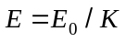. The dielectric constant is a measure of the extent to which the polarization of the dielectric decreases the electric field between the capacitor plates. The greater the cancelation of the field, the larger the dielectric constant. For a conductor the induced charges totally cancel the electric field, the electric field in the conductor is zero. This corresponds to .

Q24.21 The oil has dielectric constant 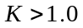. A charge separation in the oil produces an electric field that partially cancels the electric field due to the charge on the plates, so the electric field between the plates decreases. The net electric field between the plates could be measured by measuring the force on a test charge placed in the oil between the plates.

